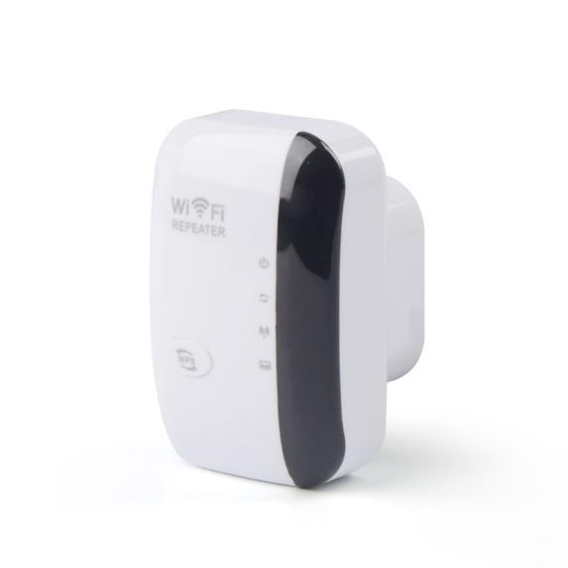
Product characteristics
- Support relay mode, AP mode;
- Built-in 100~240V 50/60Hz AC power module, no external power adapter;
- 2.4GHz band, better wall-penetrating ability, wide coverage, stable and reliable wireless transmission;
- Professional intelligent WiFi relay, support WiFi hotspot automatic scanning, and WiFi hotspot memory function;
- Support WEB background Chinese-English dual language interface, one-click setting wizard, quick and simple configuration;
- With good compatibility, compatible with all smart phones, tablets, laptops and other WiFi devices;
- Support a keyboard pop-up window setting, without complex operations.

Product Specifications
Product Name |  | 300M 2.4G Wireless Repeater
Product Model |  | Z300B
Hardware Specifications
Hardware System | Master chip |  | QCA9535
Hardware System | FLASH |  | 1MB
Wireless Parameters | Protocol standards |  | Support for IEEE 802.11b/g/n
Wireless Parameters | Operating frequency band |  | 2.4 GHz
Wireless Parameters | Wireless rate |  | 300Mbps
Wireless Parameters | Transmit power |  | 17dBm ± 2dBm
Wireless Parameters | Antenna |  | Built-in antenna *2
Wireless Parameters | Reception sensitivity |  | -90dBm ± 2dBm
Physical interface | Network interface |  | 1* 10/100Mbps RJ45 LAN port
Physical interface | Button |  | Reset key*1，WPS key*1
Indicator Light | LED indicator |  | In order：POWER/ WPS/ WIFI/ LAN
Power Supply/  Power Consumption | Mode of power supply |  | AC 100~240V 50/60Hz
Power Supply/  Power Consumption | Plug-type |  | Support European, British, US, Australian and other specifications (optional)
Power Supply/  Power Consumption | Overall power |  | < 5 w
Power Supply/  Power Consumption | Device host |  | 300M 2.4GHz repeater host *1
Power Supply/  Power Consumption | Other |  | User Manual *1, Warranty card *1, Certificate *1
Appearance/Packaging | Product dimensions |  | 79mm*50mm*65mm (L*W*H)
Appearance/Packaging | Appearance color |  | White& Black
Appearance/Packaging | Weight |  | < 250 g
Appearance/Packaging | Package size |  | 112mm*68mm*100mm (L*W*H)
Appearance/Packaging | Number of boxes |  | 80pcs/ box
Other | Covered area |  | 0 ~ 80㎡
Other | Use environment |  | Working temperature: -10℃ ~ 55℃  Storage temperature: -40℃ ~ 70℃  Working humidity: 10% ~ 90%RH non-condensing  Storage humidity: 5% ~ 95%RH non-condensing
Software Specifications
Network | Working mode |  | Trunk mode, AP mode
Wireless Security | Wireless Security |  | Supports WPA2, WPA, WPA2-PSK AES, WEP encryption
Other | Product Features |  | Professional intelligent WIFI repeater, support hotspot automatic scanning, support WIFI hotspot memory function
Other | Number of user connections |  | Maximum number of user connections is 35
Other | System language |  | Switch between English and Chinese at will
Other | Management style |  | Web configuration management
Other | Applicable scenarios |  | Multi-home, duplex, cross-floor, rental house, apartment, villa, etc

Interface&Indicator Light description

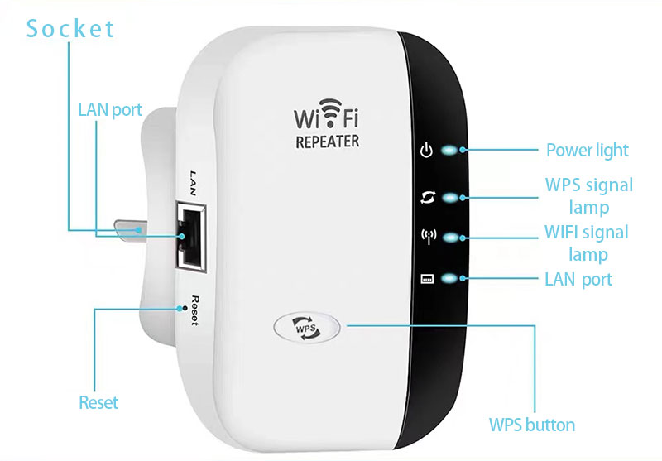

Working mode
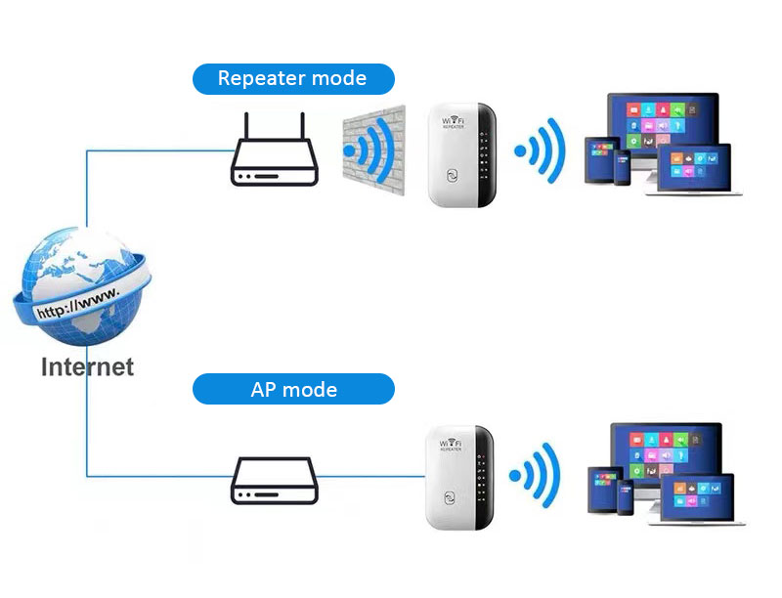
Product packaging

