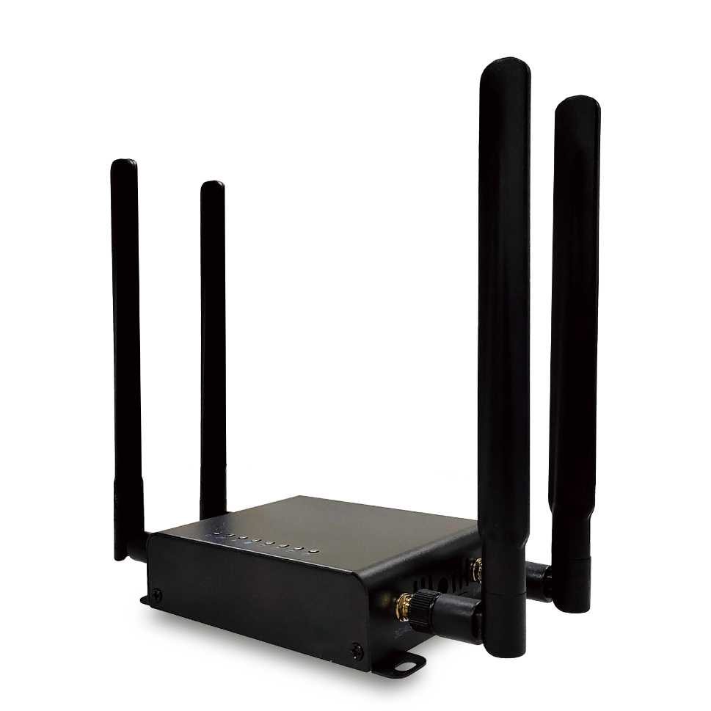

Product Characteristics
- Industrial design, equipped with all Netcom 4G module, support Mobile, Unicom, Telecom operators to choose;
- 4G to wired to WIFI signal, to meet various application scenarios;
- Large number of tape machines, easy access to a variety of wireless terminal equipment;
- No wiring, say goodbye to wired broadband, flexible installation;
- Free to change the card, plug and play, the card has a network;
- External two 2.4G,two 4G high-gain omnidirectional antennas, strong penetration, stable signal.
Product Specifications
Product Name | Industrial-grade Smart 4G Router
Product Model | RG300B
Hardware Specifications
Hardware System | Master control | MT7628DAN
Hardware System | FLASH | 8MB
Hardware System | 4G module | EC200A-CN 4G Full Netcom (optional)
Wireless Parameters | Protocol standards | IEEE 802.11b/g/ n
Wireless Parameters | Operating frequency band | 2.4GHz: 2412MHz to 2472MHz
Wireless Parameters | Wireless rate | 300Mbps Max
Wireless Parameters | 4G speed | LTE-FDD: Max downlink speed 150Mbps, Max uplink speed 50Mbps  LTE-TDD: Max downlink speed 130Mbps, Max uplink speed 30Mbps
Wireless Parameters | Transmit power | 18dBm Max
Physical Interface | Network interface | 1 10/100 Mbps RJ45 Ethernet WAN port  4 10/100 Mbps RJ45 Ethernet LAN ports
Physical Interface | Power port | 1 DC power port, support 12V DC power supply
Physical Interface | SIM card port | 1 standard self-ejecting Mini SIM card slot
Physical Interface | Key switch | 1 RESET button
Physical Interface | PCI-E interface | 1 built-in PCI-E interface (optional or replacement of different brands of 4G modules)
Physical Interface | Antenna interface | 2 4G antennas Standard SMA interface (external interface, can be replaced with different antennas)  2 WIFI antenna standard SMA interface (external interface, can be replaced with different antennas)
Indicator Light | LED indicator | In order: POWER, 4G, WIFI, WAN, LAN1, LAN2, LAN3, LAN4
Power supply/  Power consumption | Mode of power supply | DC 12V ~ 1A power supply
Power supply/  Power consumption | Machine power | < 6 w
Product Accessories | Mainframe | Industrial-grade Smart 4G Router host *1
Product Accessories | Power adapter | DC 12V/1A
Product Accessories | Antennas | 2 5dBi high gain omnidirectional WIFI antennas  2 5dBi high gain omnidirectional 4G antennas
Product Accessories | Other | User Manual *1, Warranty card *1, Certificate *1
Appearance/Packaging | Product dimensions | Overall dimensions (L * W * H) : 130mm*83mm*30mm (without antenna)  Antenna height: 172mm
Appearance/Packaging | Appearance Material | Iron shell with frosted finish
Appearance/Packaging | Exterior color | Black (appearance color can be customized)
Appearance/Packaging | Weight | < 1.5 kg
Other | Level of protection | IP31, 2KV lightning protection
Other | Installation method | Desktop, wall hanging
Other | Use environment | Working temperature: -10℃ ~ 55℃  Storage temperature: -40℃ ~ 70℃  Working humidity: 10% ~ 90%RH non-condensing  Storage humidity: 5% ~ 95%RH non-condensing
Software Specifications
Network | WAN access method | Wired, 4G
Network | Extranet address detection | Support
Network | Extranet status display | Support
Network | LAN setup | Support
Network | DHCP server | Support
Network | Uplink/downlink rate display | Support
4G dialing | 4G dialing method | Auto/manual
4G dialing | MAC address clone | Support
4G dialing | 4G signal strength display | Support
4G dialing | 4G module IMEI recognition | Support
4G dialing | SIM card number display | Support
Wireless Settings | Wireless switch | Support
Wireless Settings | SSID Setting | Support
Wireless Settings | SSID Hiding | Support
Wireless Settings | User isolation | Support
Wireless Settings | Wireless channel setup | Support
Wireless Settings | Transmit power Setting | Support
Wireless Settings | Encryption method | WPAPSK, WPA2PSK, WPAPSKWPA2PSK
Wireless Settings | Type of encryption | TKIP, AES, TKIPAES
Wireless Settings | Visitor Control | Support
Wireless Settings | QoS Settings | Support
Advanced Settings | Static routing | Support
Advanced Settings | Firewall | Support DMZ setup, port mapping, terminal management, MAC filtering, etc
Advanced Settings | System administration | Support firmware upgrade, scheduled restart, firmware file import and export, etc
Advanced Settings | System tools | PING detection, route tracing, DHCP detection

Interface Description
1. Front Interface
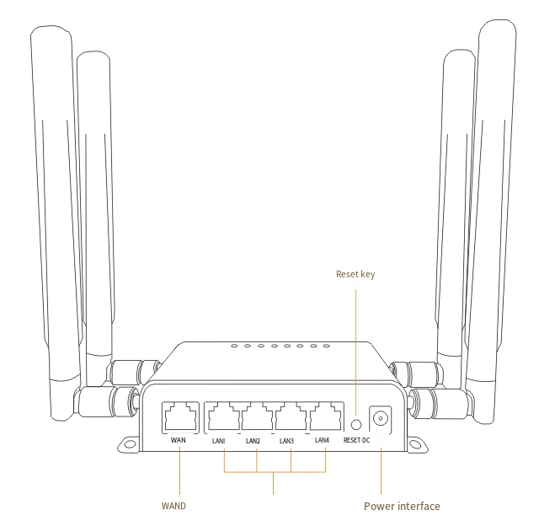
2. Side Interface

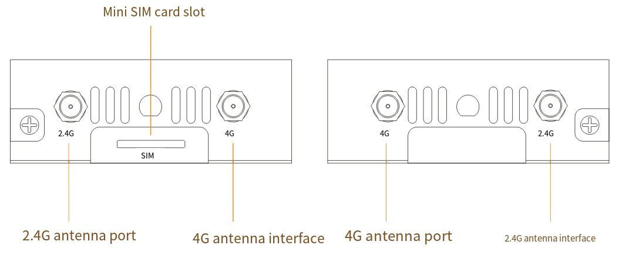

3. Packing List
