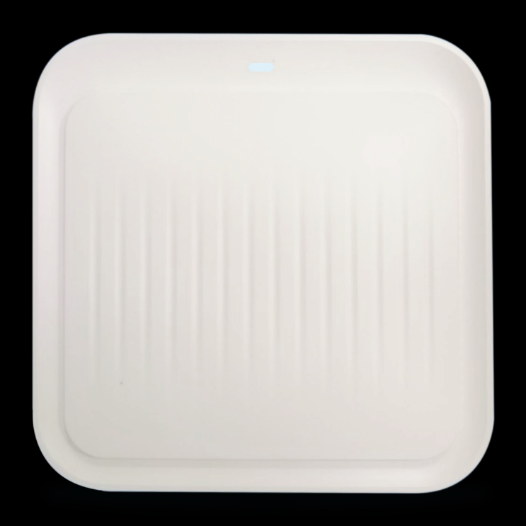

Product Description
The M-WA670 is a high-performance, high-rate 11ax indoor dual-band ceiling-mounted AP that provides 2.4G and 5GHz dual-band wireless high-rate access services, up to 574Mbps in 2.4G and 2402Mbps in 5G.
Product Features
- Adopt MT7981BA chip, support 160MHz bandwidth, greatly expand the user capacity, the maximum number of users can reach 128;
- 2.4GHz band compatibility, long transmission distance, 5GHz band interference is small, dual frequency concurrent, wireless transmission rate up to 3000Mbps, better meet the crowded places of wireless coverage needs;
- Support seamless roaming, more smooth switching, improve each user's wireless experience;
- Support automatic channel optimization, reduce mutual interference between channels, optimize the overall performance of wireless networks;
- Built-in 2 2.4G antennas, 2 5G antennas, improve the wireless signal quality of AP coverage area;
- The radio frequency adopts high power external FEM, which has stable performance, wide wireless and further transmission;
- Support AC controller unified management, one-click delivery configuration, saving labor maintenance costs;
- Support 802.3at protocol, standard 48V PoE power supply, plug and play, access wiring more flexible and convenient;
- Suitable for various crowded scenes, such as: high-speed railway stations, subway stations, terminals, hotels, hospitals, schools, scenic spots, wharves, shopping malls and other application scenarios.

Product Specifications

Product Name | AX3000 WIFI6 Dual-band Ceiling-mounted Wireless AP
Product Model | M-WA670
Hardware Specifications
CPU | MT7981BA+MT7976CN+MT7531AE
DDR3 | 256MB
FLASH | 32MB
Wireless Protocol Standards | 2.4G: Supports IEEE 802.11b /g/n/ax  5G: Supports IEEE 802.11a/n/ac/ax
Wireless Operating Bands | 2.4GHz: 2.412GHz - 2.472GHz  5GHz: 5.180GHz to 5.825GHz
Wireless Maximum Speed | 2.4G offers a maximum access rate of 574Mbps  5G offers a maximum access rate of 2,402Mbps
2.4G Transmit Power | 802.11 b |  | 11M | 24±2dBm | 1M | 24±2dBm
2.4G Transmit Power | 802.11 g |  | 54M | 21±2dBm | 6M | 23±2dBm
2.4G Transmit Power | 802.11n HT20 |  | MCS7 | 20±2dBm | MCS0 | 22±2dBm
2.4G Transmit Power | 802.11n HT40 |  | MCS7 | 20±2dBm | MCS0 | 22±2dBm
2.4G Transmit Power | 802.11ax HE20 |  | MCS11 | 18±2dBm | MCS0 | 22±2dBm
2.4G Transmit Power | 802.11ax HE40 |  | MCS11 | 18±2dBm | MCS0 | 22±2dBm
5G Transmit Power | 802.11 a |  | 54M | 19±2dBm | 6M | 22±2dBm
5G Transmit Power | 802.11n HT20 |  | MCS7 | 18±2dBm | MCS0 | 21±2dBm
5G Transmit Power | 802.11n HT40 |  | MCS7 | 18±2dBm | MCS0 | 21±2dBm
5G Transmit Power | 802.11ac VHT20 |  | MCS9 | 17±2dBm | MCS0 | 21±2dBm
5G Transmit Power | 802.11ac VHT40 |  | MCS9 | 17±2dBm | MCS0 | 21±2dBm
5G Transmit Power | 802.11ac VHT80 |  | MCS9 | 17±2dBm | MCS0 | 21±2dBm
5G Transmit Power | 802.11ax HE20 |  | MCS11 | 17±2dBm | MCS0 | 21±2dBm
5G Transmit Power | 802.11ax HE40 |  | MCS11 | 17±2dBm | MCS0 | 21±2dBm
5G Transmit Power | 802.11ax HE80 |  | MCS11 | 17±2dBm | MCS0 | 21±2dBm
5G Transmit Power | 802.11ax HE160 |  | MCS11 | 17±2dBm | MCS0 | 21±2dBm
2.4G Receiving Sensitivity | 802.11 b |  | 11M | -85dBm | 1M | -90dBm
2.4G Receiving Sensitivity | 802.11 g |  | 54M | -72dBm | 6M | -90dBm
2.4G Receiving Sensitivity | 802.11n HT20 |  | MCS7 | -70dBm | MCS0 | -87dBm
2.4G Receiving Sensitivity | 802.11n HT40 |  | MCS7 | -68dBm | MCS0 | -85dBm
2.4G Receiving Sensitivity | 802.11ax HE20 |  | MCS11 | -60dBm | MCS0 | -83dBm
2.4G Receiving Sensitivity | 802.11ax HE40 |  | MCS11 | -56dBm | MCS0 | -83dBm
5G Receiving Sensitivity | 802.11 a |  | 54M | -72dBm | 6M | -92dBm
5G Receiving Sensitivity | 802.11n HT20 |  | MCS7 | -70dBm | MCS0 | -90dBm
5G Receiving Sensitivity | 802.11n HT40 |  | MCS7 | -68dBm | MCS0 | -88dBm
5G Receiving Sensitivity | 802.11ac VHT20 |  | MCS9 | -70dBm | MCS0 | -88dBm
5G Receiving Sensitivity | 802.11ac VHT40 |  | MCS9 | -68dBm | MCS0 | -88dBm
5G Receiving Sensitivity | 802.11ac VHT80 |  | MCS9 | -58dBm | MCS0 | -85dBm
5G Receiving Sensitivity | 802.11ax HE20 |  | MCS11 | -62dBm | MCS0 | -88dBm
5G Receiving Sensitivity | 802.11ax HE40 |  | MCS11 | -58dBm | MCS0 | -86dBm
5G Receiving Sensitivity | 802.11ax HE80 |  | MCS11 | -55dBm | MCS0 | -84dBm
5G Receiving Sensitivity | 802.11ax HE160 |  | MCS11 | -51dBm | MCS0 | -82dBm
2.4G EVM | 802.11b; ≤-10dB; 802.11g; ≤-25dB; 802.11n; ≤-28dB; 802.11ax; ≤-35dB
5G EVM | 802.11a; ≤-25dB; 802.11n; ≤-28dB; 802.11ac; ≤-32dB; 802.11ax; ≤-35dB
Frequency Offset (ppm) | ±20 ppm
2.4G Antenna | 2 built-in antennas, gain: 4dBi
5G Antenna | 2 built-in antennas, gain: 4dBi
Maximum number of wireless accesses supported | 120 +
Network Interface | 2 10/100/1000M adaptive RJ45 ports with 48V PoE power supply
Reset Switch | 1 RESET button (hold down for 10-15 seconds to restore the default factory Settings)
Indicator Light | POWER indicator, LAN port indicator;  Three-color light (three different colors are denoted: SYS-red, 2.4G/ WIFI-green, 5.8G/ WIFI-blue)
Power Supply Mode | Standard PoE power supply, support 802.3at protocol;  DC 12V 1.5A
Maximum Power Consumption | < 22 w
Product Size | 196mm×196mm×40mm
Weight | < 1 kg
ESD | Air discharge +/-8K, contact discharge +/-4K
Surge | Common mode 2K, difference mode 1K
Exterior Material | Imported high quality high temperature resistant PC material
Exterior Color | White
Protection Level | IP31
Installation Method | Ceiling mounting
Product Accessories | AX3000 WIFI6 Dual band Ceiling Mounted Wireless AP *1  Quick Installation Wizard *1, Warranty Card *1, Certificate of conformity *1
Use Environment | Working temperature: -10℃ ~ 55℃  Storage temperature: -40℃ ~ 70℃  Working humidity: 10% ~ 90%RH non-condensing  Storage humidity: 5% ~ 95%RH non-condensing
Software Specifications
Working Mode | Fat and thin in one  Thin AP mode (FIT AP) : Unified management by the wireless controller (AC)  FAT AP mode (FAT AP) : Independent web page management
AC Unified Management | Support
Wireless Capabilities | SSID broadcast | Support
Wireless Capabilities | SSID hiding | Support
Wireless Capabilities | Chinese SSID | Support
Wireless Capabilities | Multiple SSIDs | Support
Wireless Capabilities | SSID Merge | Support 2.4GHz, 5.8GHz multiple bands combined into a common SSID
Wireless Capabilities | Wireless encryption | WPA, WPA2, WPA-PSK, WPA2-PSK
Wireless Capabilities | User isolation | Isolation between wireless networks and internal aps
Wireless Capabilities | White list management | Supports MAC address whitelist management
Wireless Capabilities | Transmit power settings | Support 1dBm linear adjustment
Wireless Capabilities | VLAN Settings | SSID and VLAN binding are supported
Wireless Capabilities | Limit the number of wireless clients | Support
Wireless Capabilities | Seamless roaming | Support
Maximum number of access users | 2.4 G | 60
Maximum number of access users | 5G | 60
Systems Administration | Equipment management | WEB administration
Systems Administration | System logs | Support
Systems Administration | Config down | Support
Systems Administration | Remote reboot | AC remote restart is supported
Systems Administration | Factory data reset | Support
Systems Administration | Backup configuration | Support
Systems Administration | Import configuration | Support
Systems Administration | Software upgrades | Support
Systems Administration | Ping watchdog | Support

Interface description
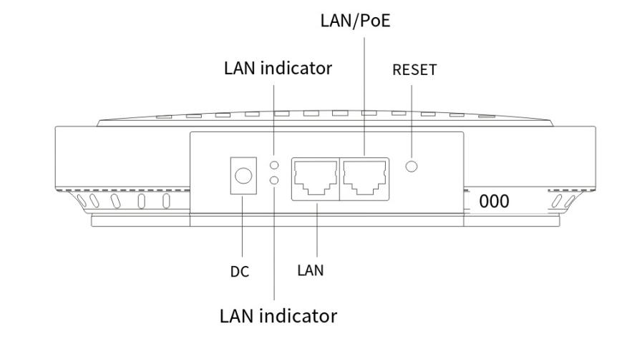

Product dimensions
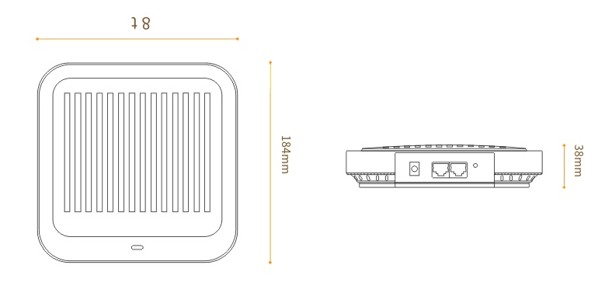

Product Networking
- Gateway Mode
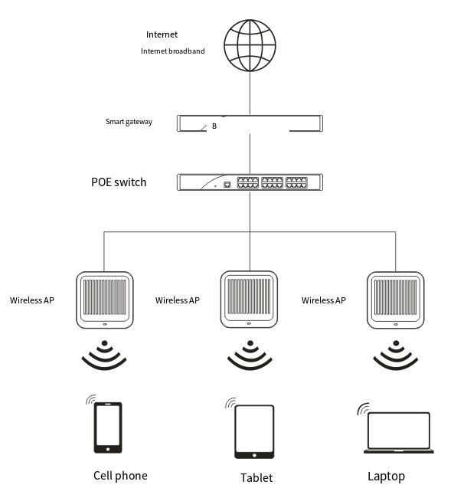
- Bypass Mode
