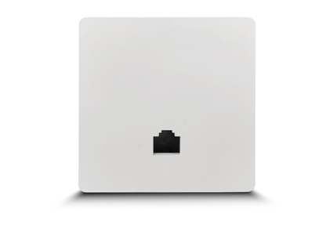
Product Characteristics
WA580 is a high-performance, high-rate 11ax indoor wall-mounted wireless AP that provides 2.4G and 5.8GHz dual-band wireless high-rate service, with 2.4G providing up to 574Mbps access rate and 5G providing up to 1201Mbps access rate.

Product Features
- Adopts standard type 86 bottom box into the wall installation, flexible and universal, simple and convenient installation;
- 2.4GHz band compatibility, long transmission distance, 5GHz band interference is small, dual frequency concurrent, wireless transmission rate up to 1800Mbps, better meet the crowded places of wireless coverage needs;
- Support seamless roaming, more smooth switching, improve each user's wireless experience;
- Support automatic channel optimization, reduce mutual interference between channels, optimize the overall performance of wireless networks;
- Built-in 2 2.4G antennas, 2 5G antennas, improve the wireless signal quality of AP coverage area;
- Fat and thin, support AC controller unified management, one-click delivery configuration, saving labor maintenance costs;
- Support 802.3af protocol, standard 48V PoE power supply, plug and play, more flexible and convenient wiring;
- The machine capacity can reach 100+;
- Suitable for all kinds of indoor scenes, such as: hotel, guesthouse, coffee shop, office, school, shopping mall and other application scenarios.

Product Specifications
Product Name | AX1800 WIFI6 Dual-band In-wall Wireless AP
Product Model | WA580
Hardware Specifications
CPU | MT7621DAT+MT7905+MT7975
DDR3 | 128MB built in
FLASH | SPI NOR 16MB
Wireless Protocol Standards | 2.4G: Supports IEEE 802.11b /g/n/ax  5G: Supports IEEE 802.11a /n/ac/ax
Wireless Operating Bands | 2.4GHz: 2.412GHz - 2.472GHz  5GHz: 5.180GHz - 5.825GHz
Wireless Maximum Speed | 2.4G offers a maximum access rate of 574Mbps  5.8G offers a maximum access rate of 1201Mbps
2.4G Transmit Power | 802.11 b | 11M |  | 17±2dBm | 1M | 18±2dBm
2.4G Transmit Power | 802.11 g | 54M |  | 16±2dBm | 6M | 17±2dBm
2.4G Transmit Power | 802.11n HT20 | MCS7 |  | 16±2dBm | MCS0 | 17±2dBm
2.4G Transmit Power | 802.11n HT40 | MCS7 |  | 15±2dBm | MCS0 | 16±2dBm
2.4G Transmit Power | 802.11ax HE20 | MCS11 |  | 15±2dBm | MCS0 | 16±2dBm
2.4G Transmit Power | 802.11ax HE40 | MCS11 |  | 15±2dBm | MCS0 | 16±2dBm
5G Transmit Power | 802.11 a | 54M |  | 16±2dBm | 6M | 17±2dBm
5G Transmit Power | 802.11n HT20 | MCS7 |  | 15±2dBm | MCS0 | 16±2dBm
5G Transmit Power | 802.11n HT40 | MCS7 |  | 15±2dBm | MCS0 | 16±2dBm
5G Transmit Power | 802.11ac HT20 | MCS7 |  | 15±2dBm | MCS0 | 16±2dBm
5G Transmit Power | 802.11ac HT40 | MCS7 |  | 15±2dBm | MCS0 | 16±2dBm
5G Transmit Power | 802.11ac HT80 | MCS9 |  | 14±2dBm | MCS0 | 15±2dBm
5G Transmit Power | 802.11aX HT20 | MCS11 |  | 15±2dBm | MCS0 | 16±2dBm
5G Transmit Power | 802.11aX HT40 | MCS11 |  | 15±2dBm | MCS0 | 16±2dBm
5G Transmit Power | 802.11aX HT80 | MCS11 |  | 14±2dBm | MCS0 | 15±2dBm
2.4G Receiving Sensitivity | 802.11 b | 11M |  | -85dBm | 1M | -90dBm
2.4G Receiving Sensitivity | 802.11 g | 54M |  | -72dBm | 6M | -90dBm
2.4G Receiving Sensitivity | 802.11n HT20 | MCS7 |  | -70dBm | MCS0 | -87dBm
2.4G Receiving Sensitivity | 802.11n HT40 | MCS7 |  | -68dBm | MCS0 | -85dBm
2.4G Receiving Sensitivity | 802.11ax HT20 | MCS11 |  | -60dBm | MCS0 | -83dBm
2.4G Receiving Sensitivity | 802.11ax HT40 | MCS11 |  | -56dBm | MCS0 | -83dBm
5G Receiving Sensitivity | 802.11 a | 54M |  | -72dBm | 6M | -91dBm
5G Receiving Sensitivity | 802.11n HT20 | MCS7 |  | -70dBm | MCS0 | -90dBm
5G Receiving Sensitivity | 802.11n HT40 | MCS7 |  | -68dBm | MCS0 | -88dBm
5G Receiving Sensitivity | 802.11ac HT20 | MCS7 |  | -70dBm | MCS0 | -90dBm
5G Receiving Sensitivity | 802.11ac HT40 | MCS7 |  | -68dBm | MCS0 | -88dBm
5G Receiving Sensitivity | 802.11ac HT80 | MCS9 |  | -58dBm | MCS0 | -85dBm
5G Receiving Sensitivity | 802.11ax HT20 | MCS11 |  | -62dBm | MCS0 | -88dBm
5G Receiving Sensitivity | 802.11ax HT40 | MCS11 |  | -58dBm | MCS0 | -86dBm
5G Receiving Sensitivity | 802.11ax HT80 | MCS11 |  | -55dBm | MCS0 | -84dBm
2.4G EVM | 802.11b; ≤-10dB; 802.11g; ≤-25dB; 802.11n; ≤-28dB; 802.11ax; ≤-35dB
5G EVM | 802.11a; ≤-25dB; 802.11n; ≤-28dB; 802.11ac; ≤-32dB; 802.11ax; ≤-35dB
Frequency Offset (ppm) | ±20 ppm
2.4G Antenna | 2 built-in antennas, gain: 3dBi
5G Antenna | 2 built-in antennas, gain: 3dBi
Maximum number of wireless accesses supported | 100 +
Network Interface | Back of the device: 1 10/100/1000M adaptive RJ45 port with 48V PoE power supply  Front of the device: 1 10/100/1000M adaptive RJ45 port
Reset Switch | 1 RESET button (hold down for 10-15 seconds to restore the default factory settings)
Status Indicator | SYS indicator light
Power Supply Mode | Standard PoE power supply  Support 802.3af protocol
Maximum Power Consumption | < 14 w
Product Size | 86mm×86mm×40mm
Weight | < 0.35 kg
Surge | Common mode 1K, difference mode 0.5K
Exterior Material | Imported high quality high temperature resistant PC material + aluminum high efficiency heat dissipation material
Appearance Color | White
Protection Level | IP31
Installation Method | In-wall installation
Product Accessories | AX1800 WIFI6 Dual-band In-wall Wireless AP *1  Quick Installation Wizard *1, Warranty card *1, Certificate of conformity *1
Use Environment | Working temperature: -10℃ ~ 55℃  Storage temperature: -40℃ ~ 70℃  Working humidity: 10% ~ 90%RH non-condensing  Storage humidity: 5% ~ 95%RH non-condensing
Software Specifications
Working Mode | Fat and thin in one,  Thin AP mode (FIT AP) : Unified management by the wireless controller (AC)  FAT AP mode (FAT AP) : Independent web page management
AC Unified Management | Support
Wireless Capabilities | SSID broadcast |  | Support
Wireless Capabilities | SSID Hiding |  | Support
Wireless Capabilities | Chinese SSID |  | Support
Wireless Capabilities | Multiple SSIDs |  | Support
Wireless Capabilities | SSID Merge |  | Support 2.4GHz, 5.8GHz multiple bands combined into a common SSID
Wireless Capabilities | Wireless encryption |  | WPA, WPA2, WPA-PSK, WPA2-PSK
Wireless Capabilities | User isolation |  | Isolation between wireless networks and internal aps
Wireless Capabilities | Whitelist management |  | Supports MAC address whitelist management
Wireless Capabilities | Transmit power setting |  | Support 1dBm linear adjustment
Wireless Capabilities | VLAN settings |  | Support SSID and VLAN binding
Wireless Capabilities | Limit the number of wireless clients |  | Support
Wireless Capabilities | Seamless roaming |  | Support
Maximum number of access users | 2.4 G |  | 50
Maximum number of access users | 5G |  | 50
Systems Administration | Equipment management |  | All Chinese WEB management
Systems Administration | System log |  | Support
Systems Administration | Config down |  | Support
Systems Administration | Remote reboot |  | AC remote restart is supported
Systems Administration | Factory data reset. |  | Support
Systems Administration | Backup configuration |  | Support
Systems Administration | Import configuration |  | Support
Systems Administration | Software upgrades |  | Support
Systems Administration | Ping Watchdog |  | Support

Product networking and application
- Gateway Mode
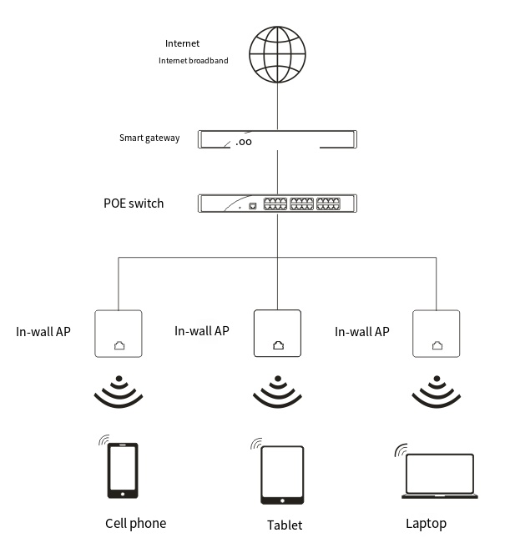

- Bypass Mode
